**1. Write a program to find the value of f(x) at a point using Lagrange’s Interpolation.**

**Algorithm:**

1. Enter the number of data points n and functional value f(x)
2. Input xp value at which interpolation is required.
3. Calculate n degree Lagrange’s Interpolation polynomial formula,

Pn(x) = $\sum_{i=0}^{n}{f_{i}l_{i}(x)}$

Where,

li(x)= $\prod_{j=0, j≠i}^{n}{\frac{x-x_{j}}{x_{i}-x_{j}}}$

1. Print the Result
2. Stop

**Source Code:**

//Lagrange's Interpolation

#include<stdio.h>

#include<math.h>

#include<conio.h>

#define MAX 10

int main()

{

int i,j,n;

float x[MAX],f[MAX],sum=0,pro,xp,fp;

printf("Enter the number of data points: ");

printf("\nn= "); scanf("%d",&n);

for(i=0;i<n;i++)

{

printf("\nInput the data points for x[%d]&f[%d]",i,i);

printf("\nx[%d] = ",i);scanf("%f",&x[i]);

printf("\nf[%d] = ",i);scanf("%f",&f[i]);

}

printf("\nInput the specified value of x: ");

scanf("%f",&xp);

for(i=0;i<=n;i++)

{

pro=1.0;

for(j=0;j<=n;j++)

{

if(i!=j)

pro=pro*(xp-x[j])/(x[i]-x[j]);

}

sum=sum+pro*f[i];

}

fp=sum;

printf("\nThe required functional value at %f = %f",xp,fp);

getch();

return 0;

}

**Output**:

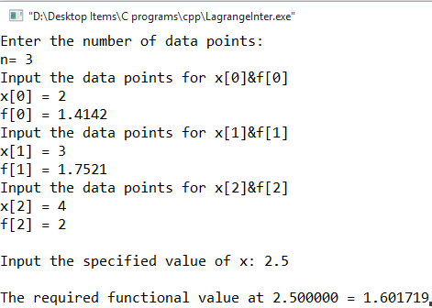

**2. Write a program to find the value of f(x) at a point using Newton’s Interpolation.**

**Algorithm:**

1. Enter the number of data points n and the functional value f(x)
2. Compute n divided difference terms as a0, a1, a2, a3, …
3. Input xp value at which interpolation is required.
4. Compute n degree Newton Interpolation Polynomial formula as

Pn(x) = a0+a1(x-x0)+a2(x-x0)(x-x1)+ …

1. Print the result
2. Stop

**Source Code:**

//Newton Interpolation

#include<stdio.h>

#include<math.h>

#include<conio.h>

#define MAX 10

void main()

{

int i,j,n;

float xp,fp,x[MAX],f[MAX],d[MAX][MAX],pro,sum=0,a[MAX];

printf("Enter the number of data points:\nn = ");

scanf("%d",&n);

for(i=1;i<=n;i++)

{

printf("\nInput the data of x[%d]&f[%d]",i-1,i-1);

printf("\nx[%d]= ",i-1); scanf("%f",&x[i]);

printf("\nf[%d]= ",i-1);scanf("%f",&f[i]);

}

for(i=1;i<=n;i++)

d[i][1]=f[i];

for(j=2;j<=n;j++)

for(i=1;i<=n-j+1;i++)

d[i][j]=(d[i+1][j-1]-d[i][j-1])/(x[i+j-1]-x[i]);

for(j=1;j<=n;j++)

a[j]=d[1][j];

printf("Enter the value of xp point : ");

scanf("%f",&xp);

sum=a[1];

for(i=2;i<=n;i++)

{

pro=1.0;

for(j=1;j<=i-1;j++)

pro=pro*(xp-x[j]);

sum=sum+a[i]*pro;

}

fp=sum;

printf("\nAt xp=%f, fp = %f",xp,fp);

getch();

return 0;

}

**Output:**

